So we just learned about some ways a model can be faulty! But that’s not the only way things can go wrong. What about bad data?
In this lab we’ll cover a few ways our data can be bad and our task will be to figure out what’s wrong with the data and improve it if we can!
1 | Dataset
Let’s load up our dataset, and use pandas to deal with it! This dataset is about the ages and treatment outcomes of patients of some mystery disease.
import pandas as pd
Then we upload our data, which is labeled patient_data.csv. df.head() just gives us the first few samples in our dataset.
df = pd.read_csv("/content/patient_dataset.csv")
df.head()
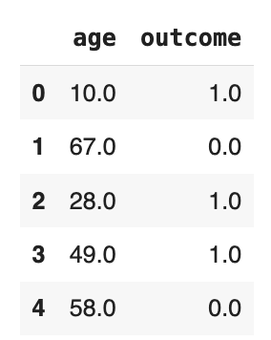
We can also check the length of the dataframe.
num_patients = len(df)
print(num_patients)
28
It looks all okay, so let’s try running a model on it!
2 | Logistic Regression
Let’s just try a simple model on it: logistic regression.
from sklearn.linear_model import LogisticRegression
log_reg = LogisticRegression()
Because we have a relatively small number of samples, we’re going to use something called leave-one-out. Essentially, we separate one sample as a test sample then train the model on the other samples. We test that one sample and repeat this for all our samples. This allows us to get a more accurate measure of the model.

3 | Leave-one-out
total_score = 0
for i in range(num_patients):
train = pd.concat([df.iloc[:i], df.iloc[i+1:]])
test = df.iloc[i]
log_reg.fit(train.iloc[:,:1], train.iloc[:,1])
if (log_reg.predict([test.iloc[:1]]) == test[1]):
total_score+=1

print("Average score:", total_score / num_patients)
What’s happening here is that we have the number of correct predictions divided by the total number of patients
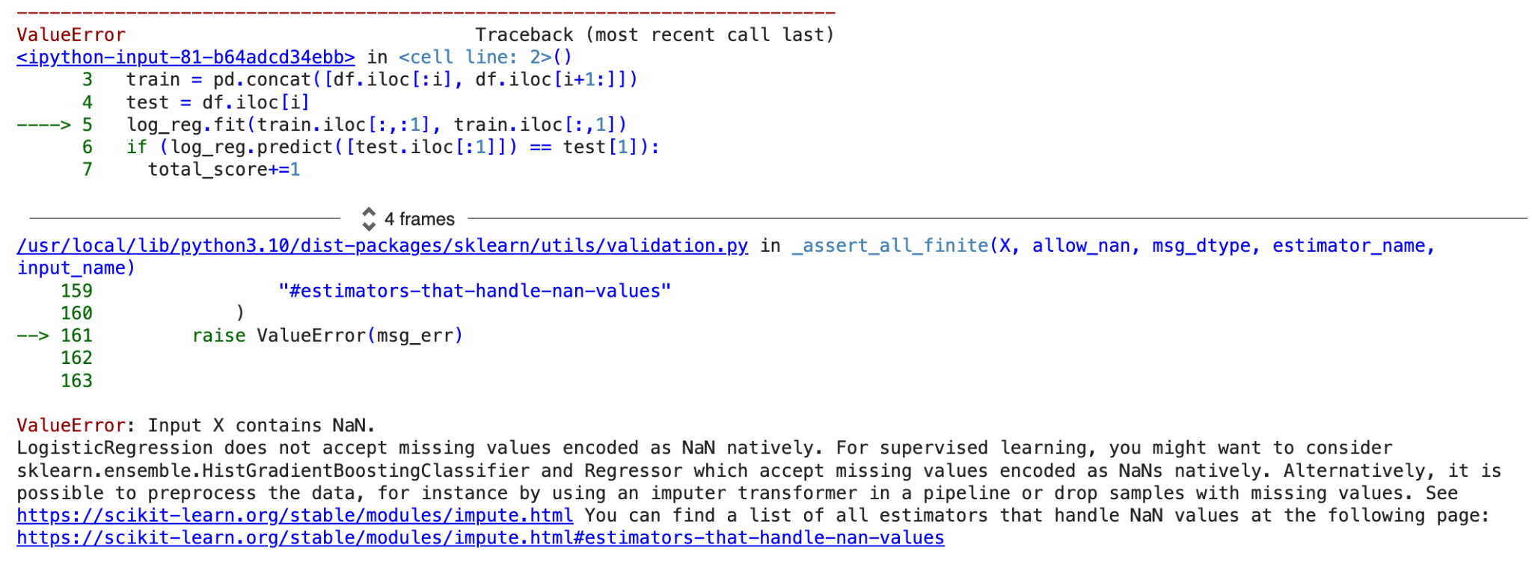
But when we run it we crash into some errors!
It says “input X contains NaN.”
Let’s take a closer look at our data…
df
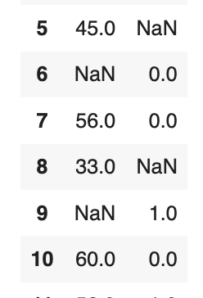
Wow! There’s a whole bunch of NaN / not a number values! Let’s make sure we didn’t mess up and go to the original data.
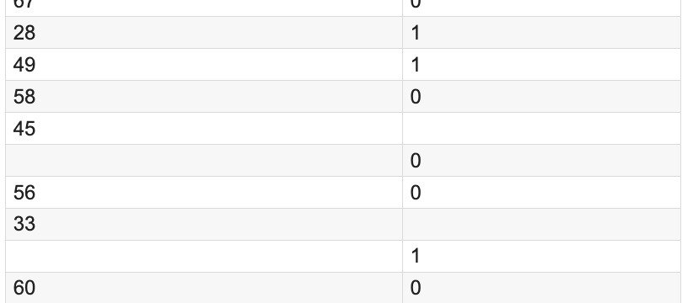
As we can see, there definitely are missing values. In some cases, we could deal with this. But since we have only one input and one output, we’re stuck with no information to try to fill in the gaps. If we had more features, maybe we could do something *wink wink* but not here.
4 | Removing values
In this case, there really is nothing we can do, so we just have to remove those values. We’ve already seen the dropna function used for dataframes all the way back on day one, so we can just use that:
df = df.dropna()
df
As we can see, all the NaN values have been removed. Now, let’s try this again.
5 | It works now!
num_patients = len(df)
total_score = 0
for i in range(num_patients):
train = pd.concat([df.iloc[:i], df.iloc[i+1:]])
test = df.iloc[i]
log_reg.fit(train.iloc[:,:1], train.iloc[:,1])
if (log_reg.predict([test.iloc[:1]]) == test[1]):
total_score+=1

print("Average score:", total_score / num_patients)
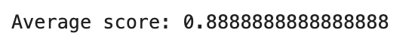
6 | Now you try!
We have a couple more datasets that have issues. Your task is to

